**MOVIE DATABASE – 3 NOVEMBER, 2021.**

* create a database, store your interesting movie names with the names of lead actor, actress, year of release and the director name. Once you have stored the details, then use any programming language of your choice to retrieve the details.

**Using SQL, we can create, insert and retrieve data stored in a Database.**

**Following are the SQL steps and commands used to output the project.**

1. **Connect to the database (username: system Password:-)**
2. **To create a Table named “Movies” in the database.**
3. **To insert values like Movie name, Actor, Actress, Year of Release and director name into the database.**
4. **To retrieve the details of a particular movie from the database.**
5. **To delete the table from database, we use drop command.**

**Commands:**

1. **create table Movies(MovieName varchar(30), Actor varchar(20), Actress varchar(20), Year_Of_Release number(5), Director varchar(20));**

**Table Created.**

**output command:**

**desc Movies**

**Name Null? Type**

**----------------------------------------- -------- ----------------------------**

**MOVIENAME VARCHAR2(30)**

**ACTOR VARCHAR2(20)**

**ACTRESS VARCHAR2(20)**

**YEAR_OF_RELEASE NUMBER(5)**

**DIRECTOR VARCHAR2(20)**

1. **insert into Movies values('MayaBazaar','NTRamaRao, ANR','Savitri',1957,'K.V.Reddy');**

**1 row created.**

**insert into Movies values('Maharshi','G.MaheshBabu','Puja Hegde',2019,'Vamshi Paidipalli');**

**1 row created.**

**insert into Movies values('Dhruva','K.Ram Charan','Rakul Preet Singh',2016,'Surender Reddy');**

**1 row created.**

**insert into Movies values('Baahubali','U.Prabhas','Anushka Shetty',2015,'S.S. Rajamouli');**

**1 row created.**

**insert into Movies values('Stalin','Chiranjeevi','Trisha',2006,'A.R.Murugadoss');**

**1 row created.**

**insert into Movies values('Tagore','Chiranjeevi','ShriyaSaran,Jyothika',2003,'V.V.Vinayak');**

**1 row created.**

**insert into Movies values('Raees','Shah Rukh Khan','Mahira Khan',2017,'Rahul Dholakia');**

**1 row created.**

**insert into Movies values('Krrish','Hrithik Roshan','Priyanaka Chopra',2013,'Rakesh Roshan');**

**1 row created.**

**insert into Movies values('Bajirao Masthani','Ranveer Singh','Deepika Padukone',2015,'SanjayLeelaBhansali');**

**1 row created.**

**Output command:**

**desc Movies**

**Name Null? Type**

**----------------------------------------- -------- ----------------------------**

**MOVIENAME VARCHAR2(30)**

**ACTOR VARCHAR2(20)**

**ACTRESS VARCHAR2(20)**

**YEAR_OF_RELEASE NUMBER(5)**

**DIRECTOR VARCHAR2(20)**

1. **select *from Movies;**

**MOVIENAME ACTOR ACTRESS**

**------------------------------ -------------------- --------------------**

**YEAR_OF_RELEASE DIRECTOR**

**--------------- --------------------**

**MayaBazaar NTRamaRao, ANR Savitri**

**1957 K.V.Reddy**

**Maharshi G.MaheshBabu Puja Hegde**

**2019 Vamshi Paidipalli**

**Dhruva K.Ram Charan Rakul Preet Singh**

**2016 Surender Reddy**

**MOVIENAME ACTOR ACTRESS**

**------------------------------ -------------------- --------------------**

**YEAR_OF_RELEASE DIRECTOR**

**--------------- --------------------**

**Baahubali U.Prabhas Anushka Shetty**

**2015 S.S. Rajamouli**

**Stalin Chiranjeevi Trisha**

**2006 A.R.Murugadoss**

**Tagore Chiranjeevi ShriyaSaran,Jyothika**

**2003 V.V.Vinayak**

**MOVIENAME ACTOR ACTRESS**

**------------------------------ -------------------- --------------------**

**YEAR_OF_RELEASE DIRECTOR**

**--------------- --------------------**

**Raees Shah Rukh Khan Mahira Khan**

**2017 Rahul Dholakia**

**Krrish Hrithik Roshan Priyanaka Chopra**

**2013 Rakesh Roshan**

**Bajirao Masthani Ranveer Singh Deepika Padukone**

**2015 SanjayLeelaBhansali**

**9 rows selected.**

1. **Specific Selection of data:**

**select * from Movies where Actor='Shah Rukh Khan';**

**MOVIENAME ACTOR ACTRESS**

**------------------------------ -------------------- --------------------**

**YEAR_OF_RELEASE DIRECTOR**

**--------------- --------------------**

**Raees Shah Rukh Khan Mahira Khan**

**2017 Rahul Dholakia**

**SQL> select * from Movies where Actress='Anushka Shetty';**

**MOVIENAME ACTOR ACTRESS**

**------------------------------ -------------------- --------------------**

**YEAR_OF_RELEASE DIRECTOR**

**--------------- --------------------**

**Baahubali U.Prabhas Anushka Shetty**

**2015 S.S. Rajamouli**

**SQL> select * from Movies where Director='V.V.Vinayak';**

**MOVIENAME ACTOR ACTRESS**

**------------------------------ -------------------- --------------------**

**YEAR_OF_RELEASE DIRECTOR**

**--------------- --------------------**

**Tagore Chiranjeevi ShriyaSaran,Jyothika**

**2003 V.V.Vinayak**

1. **To delete the table from Database:**

**drop table Movies;**

**Output Screenshots:**

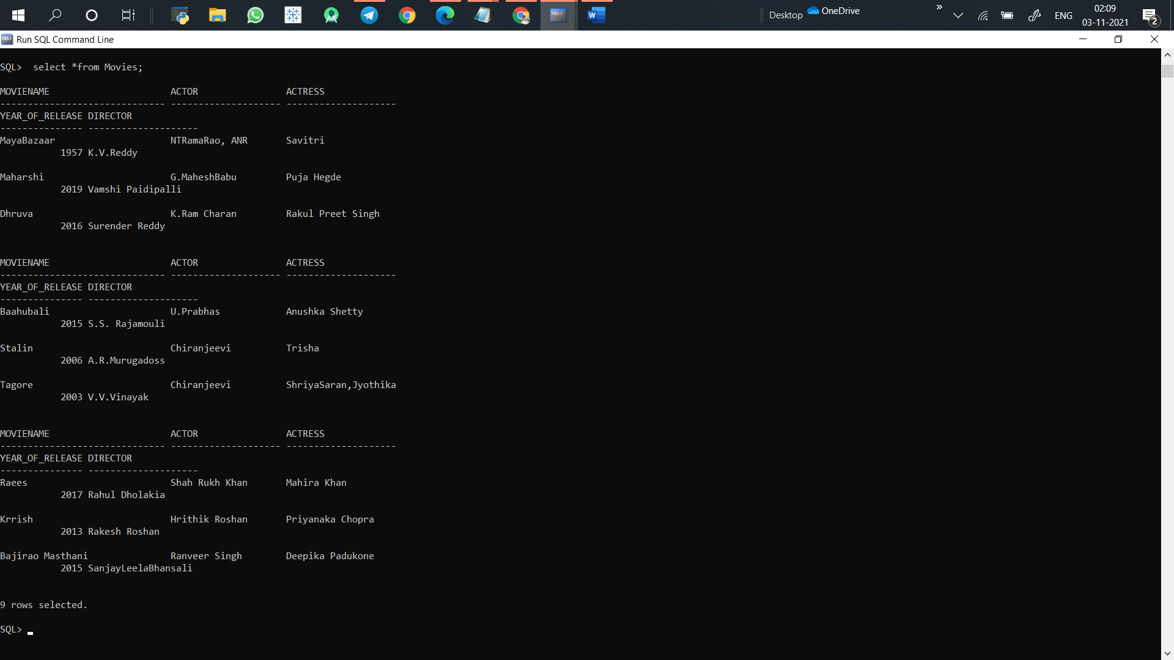

**Name: Alekya Kilaru**

**College: K L UNIVERSITY**

**Year: 4 (B.Tech)**

**Dept: CSE**

**ID: 180030554**